***CURRICULUM VITAE***

**BARNALI GORAI** 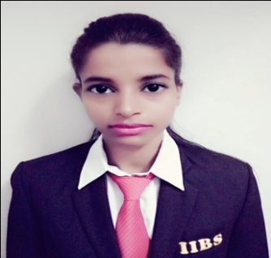

Cell No: +918509108876

E-mail: [barnali282@gmail.com](mailto:barnali282@gmail.com)

………………………………………………………………………………………………………………………………………….…………………

**Career Objective:**

“I would like to apply my knowledge and skill to enhance my potential to the growth of the organization as well as myself and willing to work in a competitive environment, which provides me an opportunity to learn and make sincere contribution to the organization”.

**Summary of Experience:**

1. **IDEA Cellular Ltd.**

(22th January. 2016 to March 2017)

Designation ----- As a Business Development Executive

1. **In Shriram Fortune Solution limited, at Salt Lake – “East Region”. )**

(6th July. 2015 to 31th December 2015)

Designation ----- Business Development Executive

**General Skill:**

* Flair written and verbal communication skills.
* Excellent work ethic and pleasing personality.
* Ability to work in a fast –paced team environment.
* Hard working and open to challenging environment.
* People skills –a good interacting personality.Multi-tasking ability to respond to rapid changes organize priorities and perform work with minimal supervision.
* Journal Entries & General Ledger

**Academic Qualification:**

|  |  |  |  |  |
| --- | --- | --- | --- | --- |
| **Exams** | **University/Board Name** | **School/Collage Name** | **Year of passing** | **% of marks** |
| MBA (Marketing &Finance) | Bharathiar University | International Institute of Business Studies | 2017 | 61% |
| B.COM (H) | Burdwan University | Panchakot Mahavidhyalaya | 2013 | 41% |
| Higher Secondary Examination | WBCHSE | Santinagar Vidhyamandir (H.S.) | 2010 | 62% |
| Secondary  Examination | WBBSE | Burnpur Subhaspally Vidhyaniketan Girls High School | 2008 | 53% |

**Additional Skills:**

* MS Office (Word, Excel, Power Point)

Internet Application

Fundamentals of Computer

Tally- 7.2

**Strengths:**

* Positive attitude
* Ability to face practical challenges
* Ability to lead and work with team
* Interact with people from different backgrounds/culture

**Special Interest / Hobbies:**

* Book Reading,
* Painting

**Personal Information:**

**Father’s Name :** Mr. Subhas Chandra Gorai

**Date of Birth :** 4Th July. 1992

**Sex :** Female

**Nationality :** Indian

**Religion :**  Hindu

**Marital Status :** Unmarried

**Language Known:** English, Hindi and Bengali

**Local Add:** C/O- Ratan Sardar, Narendrapur, Sardar Para, Narendrapur Railway Station,

Kolkata l- 700152 West Bengal

**Permanent Add :** Village + P.O: Santa, P.S: Hirapur : Via- Burnpur

Dist: Burdwan, State: West Bengal, Pin No: 713325

Phone No: +918509108876

**DECLARATION**

I the undersigned hereby declare that the information given above is true and correct to best of my knowledge.

**Place:** **KOLKATA**

**Date:** / / 2017 ………..…………………..

***BARNALI GORAI***